TechMart | Sales Performance Analysis
  - Lesson 16 - SQLite / DBeaver – January - June 2023 and January - June 2024
- Introduction
In this assignment, I analyzed TechMart sales data to understand product performance.
I used SQL in DBeaver to create tables, manage sales records, calculate units sold, and identify top-selling products.
The dataset contains 4 products and 50 sales records, with 1,136 units sold in total.
My analysis focuses on the number of products sold, not the money earned, because the data provided does not include product prices.

2. Database Setup
For this assignment, I used my existing SQLite SQL Challenges database.
I also noticed the instructions mention creating a database named sqlbasics. However, the assignment introduction asks us to create the Products and Sales tables in the SQL Challenges database. For this reason, I continued using the existing database.
I created two tables named TechMart_Products and TechMart_Sales. I used these names because I already had other Products and Sales tables from previous exercises.

2.1 Creating the tables
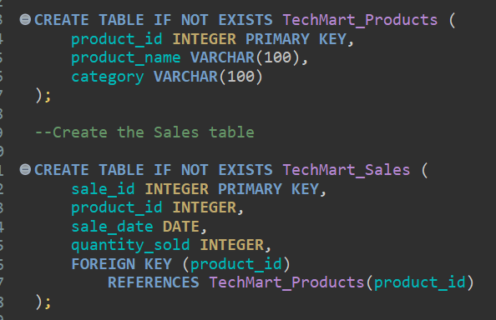
I used CREATE TABLE to create the two tables.
The Products table stores the product ID, product name, and category. The Sales table stores the sale ID, product ID, sale date, and quantity sold.
I used product_id to connect the two tables because each sale belongs to a product.

2.2 Adding the data
After creating the tables, I used INSERT INTO to add the product information and the 50 sales records provided for the assignment.
I then checked the number of records in each table.
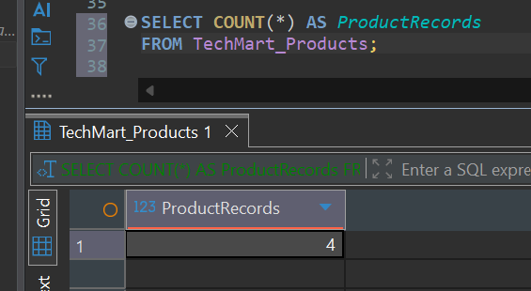

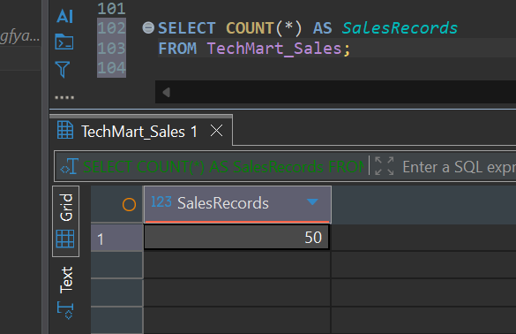
I used COUNT (*) to count the number of records in each table. This confirmed that I had 4 products and 50 sales records before I started my analysis. 3. Total Sales for Each Product
My first task was to calculate the units sold for each product.
I used the following query:
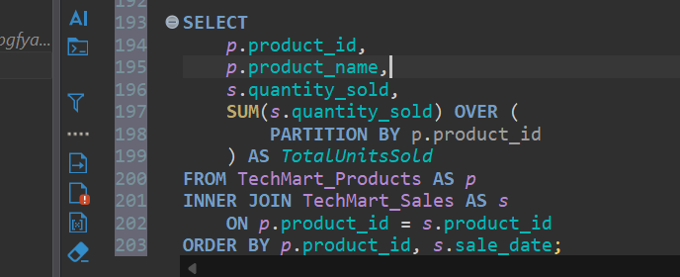
I used INNER JOIN to connect the Products and Sales tables using product_id.
I used SUM() with OVER (PARTITION BY p.product_id) to calculate the total quantity sold for each product.
My query returned 50 rows because it kept all the individual sales records. The total quantity sold for each product appears repeatedly beside its sales records.
To make the results easier to read in my report, I summarized the totals into a table showing one row for each of the four products.
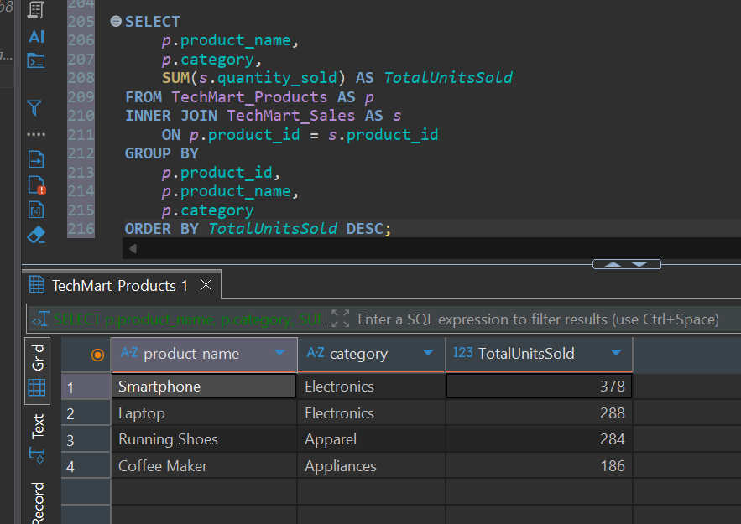

What I learned:

From the results, I can see that Smartphone had the highest number of units sold, with 378 units.

Coffee Maker had the lowest number, with 186 units.

This tells me which products sold the most units, but it does not tell me which product made the most money.

4. Monthly Sales Analysis Next, I wanted to understand how sales changed from month to month.

I used the following query:
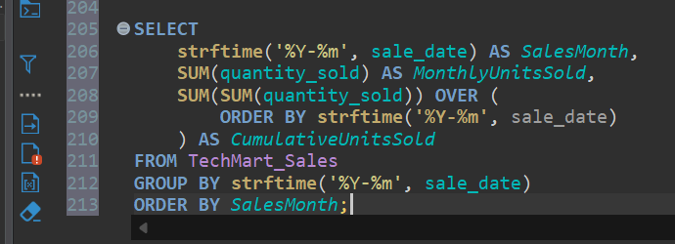

I used strftime('%Y-%m', sale_date) to show the year and month of each sale.
I used SUM(quantity_sold) to calculate the total units sold each month.
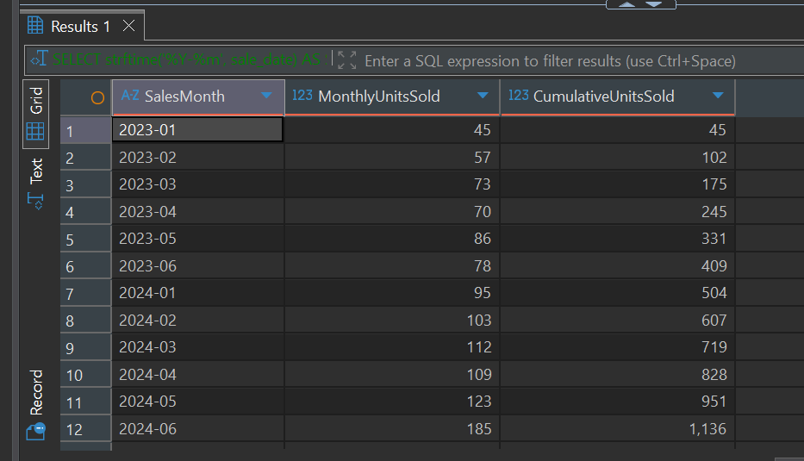
I then used SUM() OVER (ORDER BY ...) to calculate the cumulative total. This means the total keeps increasing as each month's sales are added.

What I learned:

Looking at the results, I noticed that sales were higher in the first six months of 2024 compared with the same months in 2023.

January–June 2023: 409 units

January–June 2024: 727 units

This is an increase of approximately 77.8%.

June 2024 had the highest monthly sales, with 185 units.

The data only covers January to June of each year, so I cannot make conclusions about the remaining months.

5. Ranking the Top Products
For this part, I wanted to identify the three products with the highest number of units sold.
I used a CTE and the RANK() function.
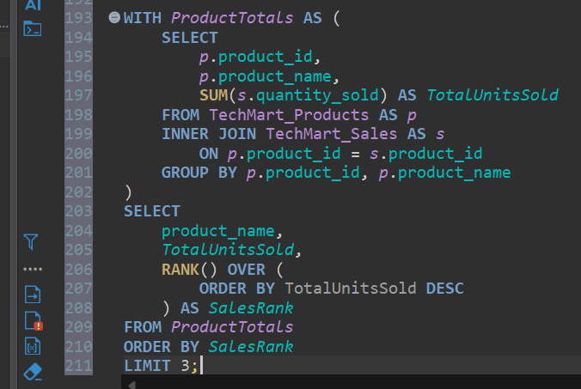

I used WITH ProductTotals AS to create a CTE. My understanding is that a CTE is a temporary result that I can use in the main query.

Inside the CTE, I calculated the total units sold for each product.

I then used RANK() to assign each product a rank based on units sold, with 1 being the highest.

I used DESC to arrange the results from highest to lowest and LIMIT 3 to display only the top three products.
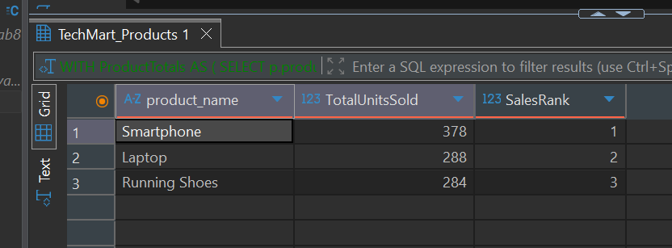
What I learned:
Smartphone ranked first, followed by Laptop and Running Shoes.
I also learned that a CTE can help me organize a query when I need to use the result of one calculation in another part of the query.

6. Conclusion
This assignment helped me practice using SQL to analyze sales data.
I created and populated two tables, connected them using INNER JOIN, calculated total sales quantities using SUM(), and used window functions to analyze product sales and monthly totals.
I also practiced using a CTE and RANK() to identify the top three products.
From my analysis, I found that TechMart sold 1,136 units across the supplied sales records. Smartphones were the highest-selling product, and sales were higher in the first six months of 2024 than in the same period in 2023.
As I continue learning SQL, this assignment has helped me better understand how different queries can answer business questions.

